DLD1055-I
10.4” TFT LCD, 1000 nits LED Backlight, 1024x768
The DLD1055-I is a 10.4 inch industrial grade sunlight readable LCD, with high brightness 1000 nits, it produces sharp images, crisp text and lifelike colors. The Durapixel LED backlight technology ensures high reliability and low power consumption, suitable for outdoor application, kiosk, factory automation, military, transportation and gaming application.
Key Features  - 10.4” sunlight readable, high brightness  - Resolutions: 1024x768  - LED Backlight  - Aspect ratio of 4:3  - Wide temperature (-20℃~70℃)  - Low power consumption  - BL MTBF: 100,000 hours |  | 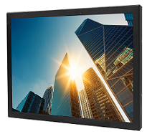
Specifications
Model Name | DLD1055-I
Description | 10.4” TFT LCD, 1000nits LED Backlight, 1024x768
Screen Size | 10.4”
Display Area (mm) | 210.432 (H) x 157.824(V) mm
Brightness | 1000 cd/m²
Resolution | 1024x768
Aspect Ratio | 4:3
Contrast Ratio | 1300 : 1
Pixel Pitch (mm) | 0.2055(H) x 0.2055(V)
Pixel Pre Inch (PPI) | 123
Viewing Angle | 176°(H),176°(V)
Color Saturation (NTSC) | 83%
Display Colors | 16.2M
Response Time (Typical) | 25ms
Panel Interface | LVDS
Input Interface | VGA, DVI-D, HDMI
Input Power | DC 12V
Power Consumption | 13W
OSD Key | 4 Keys (Power Switch, Menu, +, -)
OSD Control | Brightness, Color, Contrast, H/V Position…etc
Dimensions (mm) | 232.4 x 183 x 46.2 (T)
Bezel Size(U/B/L/R) | 12.59/12.59/10.98/10.98 mm
Mounting | 75 x 75 mm
Weight (Net) | 1.4 kg
Operating Temperature | -20℃ ~ 70℃
Storage Temperature | -30℃ ~ 85℃
DLD= Panel + LED Driving Board + AD Control Board + Chassis

Specifications are subject to change without notice.
All brands or product names are trademarks or registered trademarks of their respective companies.
 | Mechanical Drawing
Outline Dimensions Unit:mm
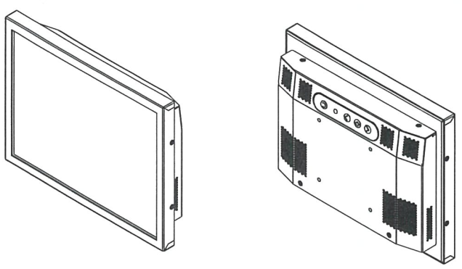
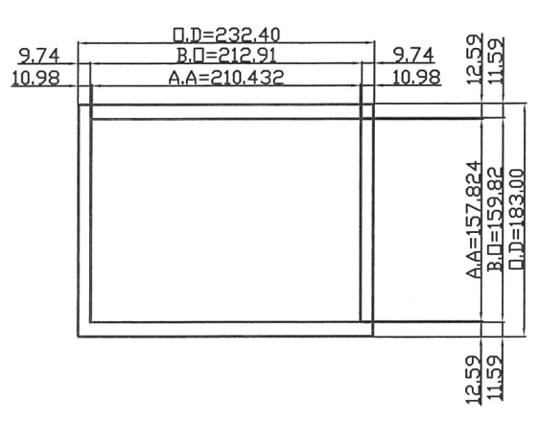

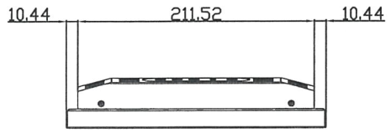

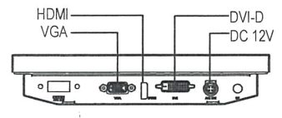

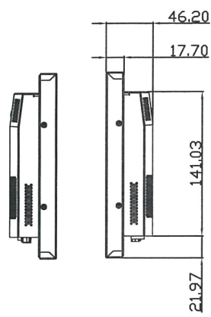
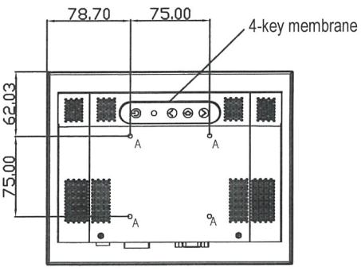

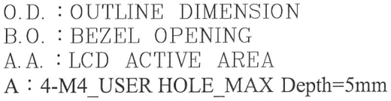

Ordering Information
Part Number |  | Description
DLD1055-INB-Q11 |  | 10.4",1000nits,1024x768,T2070,LID10C,AD8891GDH,O/B,DC12V,5in1,V1
Optional Accessories
Part Number |  | Description
810618301010 |  | CABLE,POWER,AC,1830mm USA type
810618301090 |  | CABLE,POWER,AC,1830mm Europe type
810618301050 |  | CABLE,POWER,AC,1830mm UK type
810618301170 |  | CABLE,POWER,AC,1830mm Australia type
810618301030 |  | CABLE,POWER,AC,1830mm Japan type

